**Sea Spectrum for Sea States 1-9**

**Table of contents**

1. Sea state data …………………………………………………………………………………..1
2. ITTC Formula …………………………………………………………………………………1
3. Python plot of S(w) vs w………………………………………...………………………*….. 2-3*
4. Some observations ……………………………………………………………………………*. 4*
   1. Nature of sea spectrum curve as a function of h and t
   2. Shift of average time period as sea state varies
5. **Sea State Data**

|  |  |  |
| --- | --- | --- |
| Sea State | Significant Wave Height (m) | Average time period (s) |
| 0 | 0.01 | 0.5 |
| 1 | 1.3 | 2.3 |
| 2 | 2.6 | 3.2 |
| 3 | 4.7 | 4.3 |
| 4 | 6.6 | 5.1 |
| 5 | 10.5 | 6.4 |
| 6 | 14.3 | 7.5 |
| 7 | 21 | 9.1 |
| 8 | 32.1 | 11.3 |
| 9 | 49.2 | 13.9 |

*Table 1.1 Data taken from definitions of sea conditions by L. Moskowitz and W. Pierson*

1. **ITTC Formula and Python plot for wave spectrum**

When the wave spectrum for a particular sea condition is unknown, ITTC Formulation is used:

$$S\left(ω\right)=\frac{A}{ω^{5}}*e^{-\frac{B}{ω^{4}}}$$

Where:

$$A=173*H^{2}/T^{4}$$

$$B=691/T^{4}$$

|  |  |  |
| --- | --- | --- |
| Sea State | A | B |
| 0 | 0.2768 | 11056 |
| 1 | 10.44771853 | 24.69259329 |
| 2 | 11.1530304 | 6.589889526 |
| 3 | 11.17810016 | 2.02117643 |
| 4 | 11.13918123 | 1.021403503 |
| 5 | 11.36854291 | 0.4118680954 |
| 6 | 11.18080632 | 0.2183901235 |
| 7 | 11.12548938 | 0.1007656424 |
| 8 | 10.93307668 | 0.04238032408 |
| 9 | 11.21804319 | 0.01851052968 |

*Table 2.1 Values of A and B for various Sea States*

1. **Python Code and Plot:**

import numpy as np

from matplotlib import pyplot as plt

a=[0.2768,10.44771853,11.1530304,11.17810016,11.13918123,11.36854291,11.18080632,11.12548938,10.93307668,11.21804319]

b=[11056,24.69259329,6.589889526,2.02117643,1.021403503,0.4118680954,0.2183901235,0.1007656424,0.04238032408,0.01851052968]

x=np.linspace(0, 15, 250, endpoint=True)

for i in range(9):

y=a[i]/pow(x,5)*np.exp(-b[i]/pow(x,4))

plt.plot(x,y, label='Sea State')

plt.xlabel("frequency, hertz")

plt.ylabel("S(w)")

plt.title("Sea Spectrum for Sea States 0-9")

plt.legend()

plt.show()

**3.1 Output:**

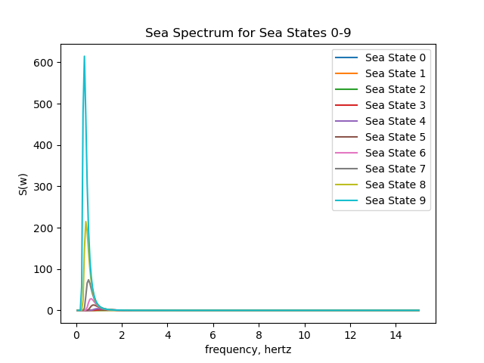

**3.2 Magnified view of sea states:**

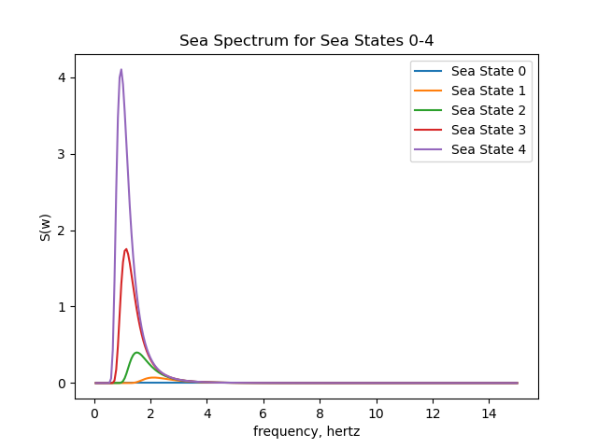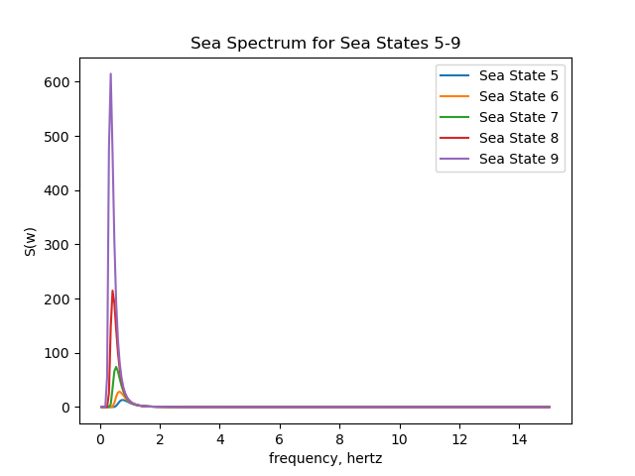

1. **Observations** 
   1. As the sea state increases, and the sea becomes rougher, the wave spectrum curve is skewed more and more to the left. The peak wave height increases as well.
   2. The point of occurrence of peaks shifts towards the left as well. As the sea state increases, average time period increases, which can be explained by how the waves get bigger and larger in sea states 5-9 when compared to the lower sea states. The peak occurs at a lower value of frequency. Since time period is inversely proportional to frequency, we can say that the peak time period of waves increases with rougher seas as well.